**SPL-1 Project Report** 

**Store Management System**

Submitted by

***Abdus Salam Islam Badhon***

**BSSE Roll No. :1401**

**BSSE Session: 2021-2022**

Submitted to

[Toukir Ahammed](mailto:toukir@iit.du.ac.bd)

***Lecture IIT DU***

***Supervisor Signature : _____________________***



**Institute of Information Technology**

**University of Dhaka**

17/12/2023

# Table of Contents

1. Introduction

1.1 General Overview

1.2 Dealer Mode

1.3 User Mode

1.4 Technologies Used

1.5 Conclusion

2. Background of the Project

2.1 General Overview

2.2 Evolution of Online Retail

2.3 Inspiration and Objectives

2.4 Scope and Limitations

2.5 User-Centric Design

2.6 Conclusion

3. Description of the Project

3.1 Project Overview

3.2 Products and Users

3.2.1 Product

3.2.2 Product Related Features

3.2.3 User

3.2.4 User Related Features

3.3 Dealers and Customers Features

3.3.1 Dealers Features

3.3.2 Customer Features

3.4 Product Categorisation

3.5 Trie Data Structure

3.6 File Based Categorization

3.7 Input Validation

3.8 Relevant Statistics

3.9 Shopping

3.10 Overall Working of Store Management System

4. Implementation and Testing

5. User Interface

6. Challenges Faced

7. Conclusion

References

# 

# 1. Introduction

## 1.1 General Overview :

The project named “Store Management System” is designed to lessen the manual work of an administrator of a typical retail shop and to give an user-friendly experience to the user who will visit the store. This project has implemented some of the basic features that are present in a typical online shopping platform.

## 1.2 Dealer Mode :

The dealer mode is for the retail shop owner. As a dealer by logging into the system he can do a number of things related to both product as well as user. Like he can add a new product, refill,reduce,apply discount,change price ,change name, remove a product, all these things. And also user related things like removing a user from the system, giving a giveaway to the user , resetting user performance and so on. As I have stored so many data points related to users and products which will help the dealer to take different actions strategically.

# 1.3 User Mode :

On the other hand the user mode deals with the features related to users. At first the user will be shown a window where he has to choose wheather he wanna sign in or sign up. By providing appropriate information he can sign in or if he doesn’t have an account yet he can create a new one. After signing in he can do a lot of things like changing his existing account details,deposit money to his account, do shopping , see recommended products, delete accounts , search products and so on.

## 1.4 Technologies Used :

The language I used was mainly c++ programming language. I also have used some features of the C programming language . I coded the whole project in vs code IDE . And I maintained the code base on github.

## 

## 1.5 Conclusion :

In conclusion I wanna state that this project will introduce the user and dealer to the huge potentiality of software solutions to perform day to day tasks and benefits of automating a retail shop tasks . This project will work as a prototype which very highly mimics the working of an online retailing shop and can be a very good reference for creating such a system.

# 

# 2. Background of the Project

# 

## 2.1 General overview :

As it is my first software project after enrolling to the program of software engineering at Dhaka University and being someone who does not have any prior knowledge or experience in making or dealing with software I tried to make a project which I will be capable to implement and something that is in so much use in our day to day life. So I decided to create this project named “Store Management System” for my spl-1.

# 2.2 Evolution of Online Retail :

I chose to create this project because I thought in this age of information technology era the more we adapt to the use of technology the better. If we look at amazon( the largest online retailing platform) it has changed the way we do shopping. Now we can order almost anything of our day to day life and within a short period of time it appears to us. This helps us to choose the correct categories and related features of a product and we don't need to bargain; we can buy the product at the correct price without any hardships. So these are some of the things which were the motivation for me to make this project for my spl-1.

## 2.3 Inspiration and Objectives :

My inspirations to make this project to showcase the capabilities of information technology and its uses in our daily life. And some of my objectives are to provide a user -friendly platform for shopping and helping the dealer to manage inventory.

## 2.4 Scope and Limitations :

As I already mentioned this project can be a very good prototype for an online shopping platform. But this project is not made online. This is created by using only c++ language so I could not apply all the rich features related to UI and other things. My knowledge was also a limitation. And this project works on a terminal with basic text based UI and without networking support. But in the future I would like to learn about those technologies to make this software more sophisticated.

## 2.5 User-Centric Design :

As the whole project and the system is designed to operate with the user and customers. So I tried to create so many menus and submenus to give users a way to deal with the system with ease. I tried to create a text based basic user interface so that I can give the user a good environment to see different features like list of products, recommended products and so on.

## 2.6 Conclusion :

In conclusion I would like to thank my supervisor, respected Toukir Ahammded sir, for suggesting to me so many things regarding the projects from making of the srs(software requirement specification) to implementing different parts and suggesting different features of the projects . I hope it would give a good general overview of capabilities of a store management system.

# 3. Description of the Project

# 3.1 Project Overview :

Now let's talk about the brief overview of the overall architecture and working of the project. As there are so many features in the project I tried to separate different features by placing different codes to different files. So a file contains only the related code. And all the files combinedly make the overall systems working. I tried to maintain proper naming conventions to increase readability and maintenance. I also tried to make the code more efficient by applying different algorithms,data structures and programming techniques. I tried to reuse existing code as much as possible to implement different features. Different parts of the codebase got executed based on the mode getting operated. So all these things will increase the efficiency of the whole project. Some of the projects working and architecture along with the breakdown of the source code will be discussed below.

# 3.2 Products and Users :

The system will deal with both user data and product data . The user will deal with the product to buy,rate and to do other things. Actually we care about both the user related data and the product related data. So I tried to maintain both user data and product data as dynamic as possible with the running of the code . Which will help in performing different tasks related to them.

# 3.2.1 Product :

The product is an integral part of the overall system. It contains all the data related to a product like id,name,price,quantity,sales,discount,rating and so on. All of these data points and variables are declared inside a class named “Product” which encapsulates all the product related data. Inside this “Product” named class I declared constructors related to the class. I also defined all the instances as private and defined so many methods/functions related to the instances of the class to set and get access to the data which satisfy the encapsulation concepts.

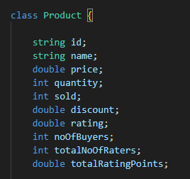

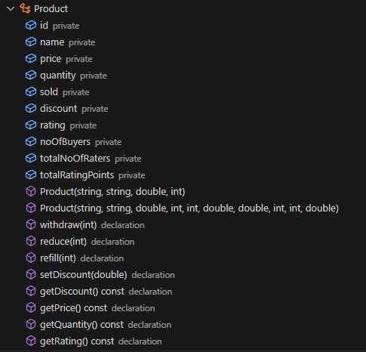

# 3.2.2 Product Related features :

After declaring the product related data and their methods we can do a lot of things on these data points. As we will store the product data in a file so I have declared functions regarding reading and writing product data to the files. I have also implemented functions related to displaying all product details, displaying product details based on certain statistical categories like based on rating ,no of buyers, total sales,total revenue m,discount ,no of stocks and so on.

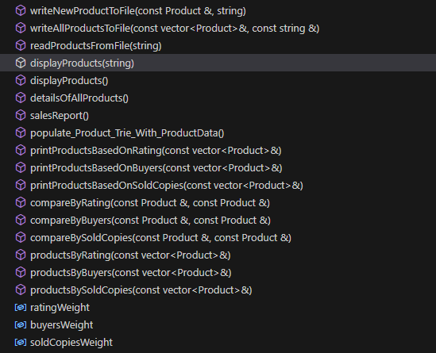

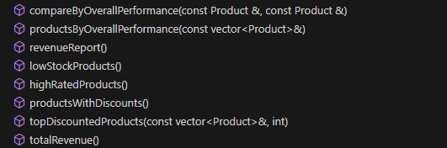

# 

# 

# 3.2.3 User :

At the end of the day it's the user who will purchase from the system. So to deal with the user data I have declared a class named “User” which will encapsulate user related data like id,name,password,balance and total purchases. I have declared constructor related to the class and declared necessary functions/methods to get and set the user data. All the user data is private and only can be accessed by the getter functions. Which add security to the user data.

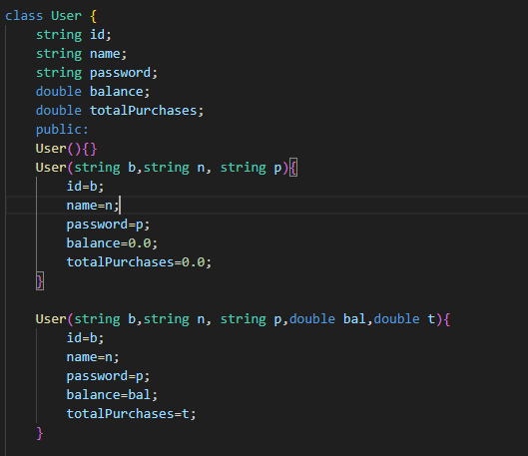

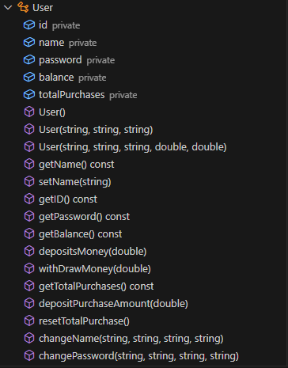

**3.2.4 User Related features :**

The user can do a number of things on the system. First of all I declared necessary functions to write and read user data to and from the file.I also wrote functions to make user capable to see users based on certain criteria like maximum total purchases , average total purchases and so on.

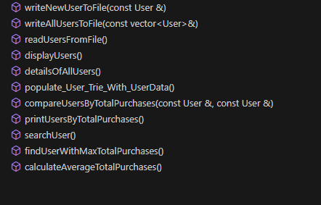

# 

# 3.3 Dealers and Customers Features :

# 3.3.1 Dealers Features :

As the owner of the shop the dealer can do a lot of things related to both users and products. Like if he feels some products need to be refilled/reduced/removed he can do that. He is also able to change product related information like name , discount, price and so on. Being the owner of the system he has also the authority to remove a particular user from the system if necessary. He can also perform giveaways from time to time to reward users with the most purchases and also reset user performance to start fresh counting of the user's total purchases. He can also search a particular product and user by name and id.

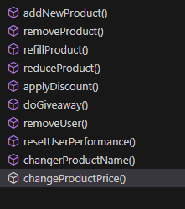

# 3.3.2 Customer Features :

Users already signed in on our system are addressed as customers. A user has to sign in to use the system by providing necessary information. If the user does not have an account yet he has to create an account and then sign in. After sign in he can do things like changing account details(name,passwords),shopping,deposit money,search product,rate a product and so on.

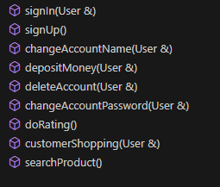

# 

# 3.4 Product Categorization

The system creates different categories of products. This categorization gives ease to the dealer to manage inventory and also the user to deal with the inventory from better user experience for shopping. All these different categories of products are stored in different files. Some of the categories that I have already implemented are: 1. Grocery 2. Foods and beverages 3. Electronics 4. Books and stationary 5. Fashion and Beauty 6. Healthcare 7. Home appliances.

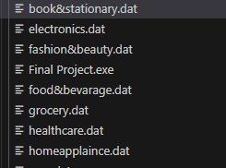

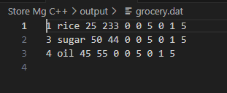

# 3.5 File Based Categorization

The project consists of multiple files for storing the product details as well as the source code files. By fragmenting the overall source code it has become easier to maintain and read different parts of the project. By proper linking of all these source code files the overall project works seamlessly. Similar operations performing code are placed in a single file to maintain modularity.

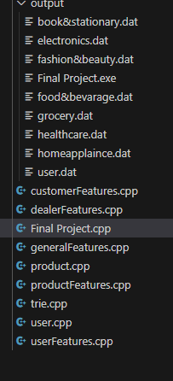

# 3.6 Input Validation

As our system will need to have input from both users and dealers. We need to apply certain constraints on the input for example rating has to be in between 0-10 and price can not be negative and so on. So this has been done with certain functions shown below.

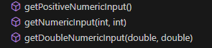

# 3.7 Trie Data Structure :

Our system uses searching extensively be it user or product. So to search a product if each time we access all the files then traverse through it linearly then it would decrease the performance highly. This was what I did in my mid term project. Then my respected sir from the panel of the exam suggested that I maintain trie data structure for efficient searching. So now in my project I maintained 4 different trie data structures named two for product and two for user. One trie is made of the ids and the other is made of id+name . As we know all the ids of corresponding products and users are unique so just by the id contained trie now we can know whether a user or product exist or not without accessing the files. If an id is found then we ask for the name. Now this works as the second level of verification. Then we used the id+name contained trie to see if the id and name were correct. As id is unique so id+name will also be unique even if name is duplicate(which is permitted like user with same name but will have different ids same concept goes for product like same name different id may refer to the flavor of the product). So by id and name we can uniquely identify a user or product. So if id+name trie don't recognise the entered id and name then we are 100 percent sure that user or product does not exist in our system. So now we can verify a user or product existence without even accessing the files and just by the trie data structure maintained by us. The system will also contain any changes like if a product or user is removed then the corresponding id and id+name entry is also removed from the trie data structures. If name change happens then trie with old data is removed and id+newname is inserted onto the trie data structures to verify further accesses. So this time to time changes and accessing the trie wholly increased the performance of the overall system by a huge margin .

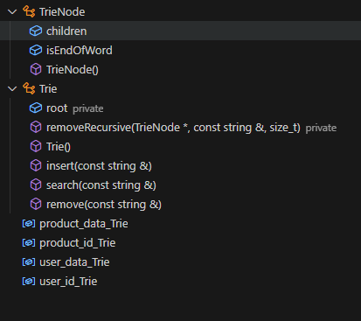

# 3.8 Relevant Statistics

Apart from the trie data structures another thing that was suggested to me was to implement relevant statistics to my project. As my project deals with so many different data points of both user and product. So I implemented some necessary statistics for betterment of both the dealer as well as the customer, like printing products based on rating ,sales,discount, and no of buyers. I also implemented sales reports ,revenue reports ,details of low stock products, user performance and so on. Which will help the dealer enormously to manage the inventory and also the customer to perform better shopping.

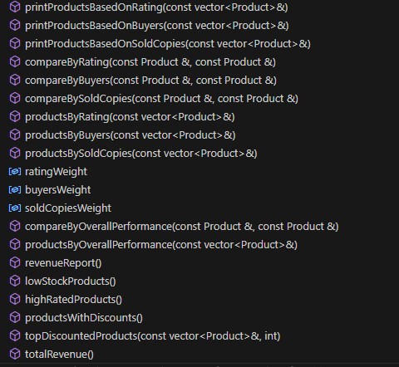

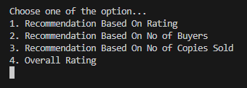

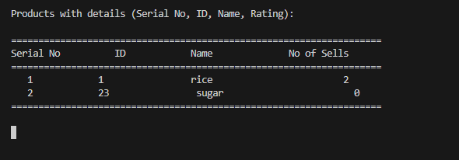

# 3.9 Shopping

After signing in, the customer will see an option of shopping. By entering that option the customer can browse through the inventory and perform shopping as long as he wants. Each time he will be asked whether the wanted to continue shopping. If not then he will see a payment receipt containing all the details of the shopping . Then he will be given two options: cancel order or go for final payment . If cancel order is selected then the order will be canceled and no modification will be applied to the user data as well as the products data. If the final payment is selected then after checking the user's existing balance if he is capable of paying the bills then he will get the product and user and product data will be modified. If not then order will be canceled without any change in data.

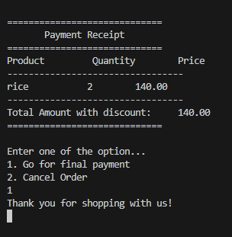

# 3.10 Overall Working of Store Management System

At the very beginning of the system all the four trie data structures will be loaded by crawling through all the product files and user files. So now we can use these data structures for any kind of further usage of searching. Then the system will show a wind to choose between dealer mode and customer mode. If dealer mode is selected then it will ask the dealer password. After verification it will show other menus and submenus to operate with the inventory and to do other dealer specific things. But if customer mode were chosen then a window will come asking to sign in or sign up. New users can sign up and old users can sign in to the system and do customers specific things discussed earlier. I tried to use a user -friendly environment for maximum benefit of both users and customers .And that's it! This is the overall working of my project named “Store Management System” for SPL-1.

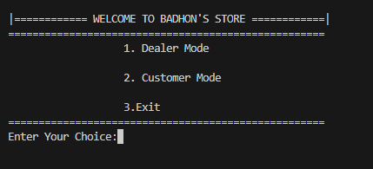

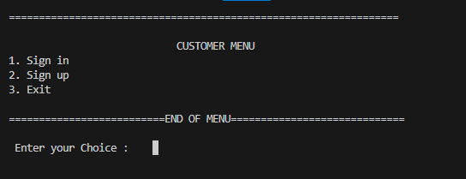

# 4.0 Implementation and Testing

After completing the project, I have to spend a lot of time checking all the features. If the input functions are correctly working or not, any changes on the product and user data are getting modified on the files or not, are all the options visible on the user interface or not. I tried with so many different input variation to look for any loophole

present or not in the system. By manually checking all the options with all possible cases the system has become secure to use .

# 5.0 User Interface

I haven’t used any sophisticated user interface in my project. As it is completely made of c++ programming language so I could not add all the rich features that are available in other programming languages. My project will run on the terminal and will take input from the user on the terminal . But I tried to provide the user a text based interface to interact with the system. And I would like to learn about more features about User Interface and other technology in future.

# 

# 

# 6.0 Challenges Faced

I have faced so many challenges in making the whole project. In the beginning it was hard to specify the software requirements . Thanks to my supervisor who helped me with that. After specifying the requirements I was completely blacked out on how to start the development so I took help from some online resources to see how the software development process goes through. Then I started coding some of the features. As new and new features are added managing the overall codebase becomes so hard. And also maintaining synchronization of all these features was also a tedious task. I have faced difficulties dealing with the files . Like the files were not getting updated based on the performance or if updated then it is wrongly updated so I have revised my code a lot times to fix certain bugs and loopholes. And also I have spent a significant amount of time deciding how the overall flow of the project will look like. So these are some of the difficulties I faced in making the project.

# 7.0 Conclusion

At last I would like to thank my supervisor respected [Toukir Ahammed](mailto:toukir@iit.du.ac.bd) sir for guiding me in making this project. I hope this project will give anyone a broad overview of how retail shop tasks can be automated through information technology. And that's it from me…

# References :

In making the project I have to deal with concepts of data structure, statistics,software engineering and programming concepts so I have used the following books as reference. I also provided a link to my github repository containing source code of the whole project.

Project link: https://github.com/Badhon1401/spl1

1. Roos, Anne M., and Roos, Anne H. *An Introduction to Statistics*. Pearson.

2. Shield, Herbert S. *C++: The Complete Reference*. McGraw-Hill Education.

3. Cormen, Thomas H., Leiserson, Charles E., Rivest, Ronald L., and Stein, Clifford. *Introduction to Algorithms*. The MIT Press.

4. Sommerville, Ian. *Software Engineering*. Addison-Wesley